Name-Riddhi Dhawan

Reg No.-20BIT0038

* The objective was to make a food webpage like zomato
* I started from the beginning and learnt each and every step along the pge
* I took coding ninga’s Youtube course on frontend for web dev
* I used carousel and cards from bootstrap
* I created a webpage where we can order food online “Food On The Go” and I also plan on adding a chatbot after learning ML and also adding a cart to the webpage
* The screenshot for the webpage is

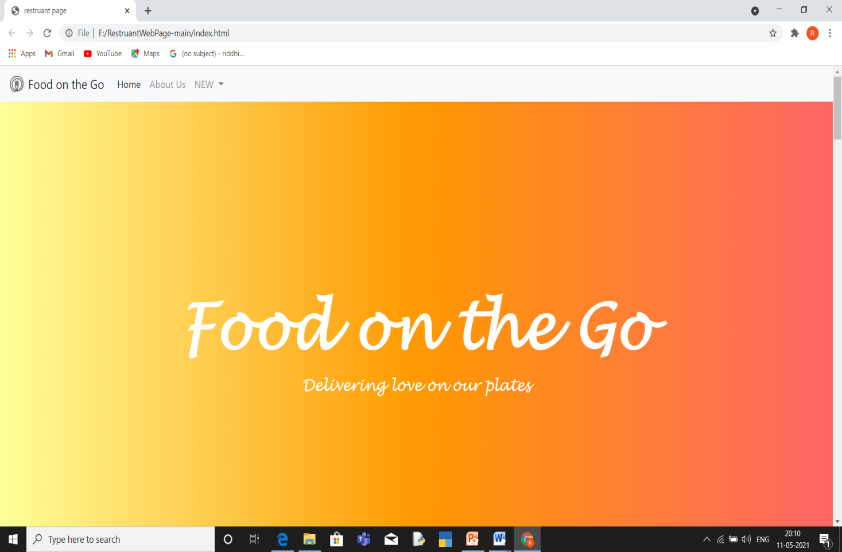

The link for the repo is:-

https://github.com/riddhidhawan/Restruant